# Project Documentation

## Project Title: FitFlex : Your Personal Fitness Companion

## 1. Introduction

• Project Title: FitFlex : Your Personal Fitness Companion

• Team ID: NM2025TMID45735

• Team Leader: LIKITHA M (likethag374@gmail.com)

• Team Members:

_ LIKITHA N (likithan713@gmail.com)

–  MADHU N (madhusaila555@gmail.com)

_MAHALAKSHMI S (mahamaha6413@gmail.com)

## 2. Project Overview

• Purpose: FitFlex is designed to be a personal fitness companion helping users track workouts, monitor nutrition, and achieve fitness goals.

• Features:

– Personalized workout plans

– Nutrition and diet tracking

– Progress monitoring with analytics

– Goal setting and reminders

– Community and social features

## 3. Architecture

• Frontend: React.js with Tailwind CSS

• Backend: Node.js and Express.js

• Database: MongoDB

• Authentication: JWT

## 4. Setup Instructions

• Prerequisites: Node.js, MongoDB, Git, Visual Studio Code

• Installation Steps:

# Clone the repository: git clone <repo_url>

# Install client dependencies: cd client && npm install

# Install server dependencies: cd ../server && npm install

# Run frontend: cd client && npm start

# Run backend: cd server && npm start

# Access at http://localhost:3000

## 5. Folder Structure

FitFlex/  
|-- client/ # React frontend  
| |-- components/  
| |-- pages/  
|-- server/ # Node.js backend  
| |-- routes/  
| |-- models/  
| |-- controllers/

## 6. Running the Application

• Frontend: cd client && npm start

• Backend: cd server && npm start

• Access: http://localhost:3000

## 7. API Documentation

• User: /api/user/register, /api/user/login

• Workouts: /api/workouts/create, /api/workouts/:id

• Nutrition: /api/nutrition/add, /api/nutrition/:id

• Progress: /api/progress/track

## 8. Authentication

• JWT-based authentication ensures secure login and protects private routes.

## 9. User Interface

• Landing Page

• Dashboard

• Workout Tracking Page

• Nutrition Tracking Page

• Progress Analytics Page

## 10. Testing

• Manual and automated testing were carried out using Postman, Jest, and Chrome DevTools.

## 11. Screenshots or Demo

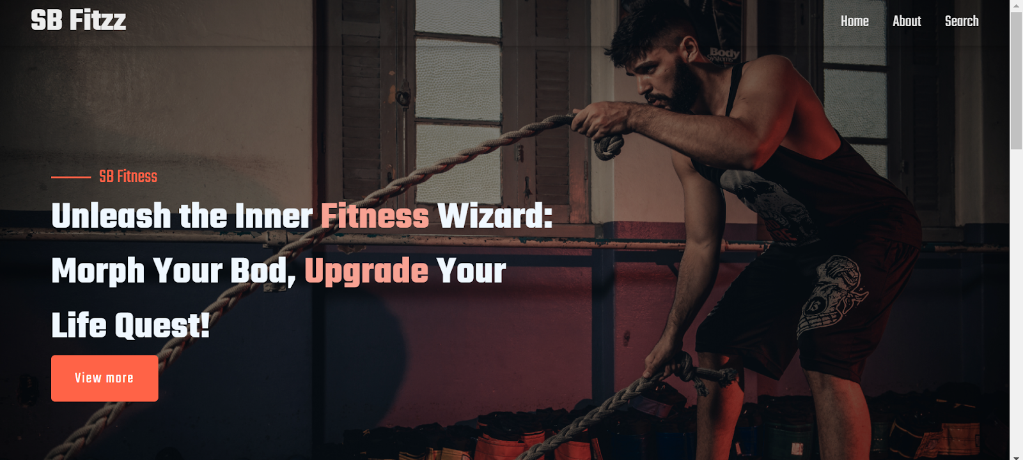

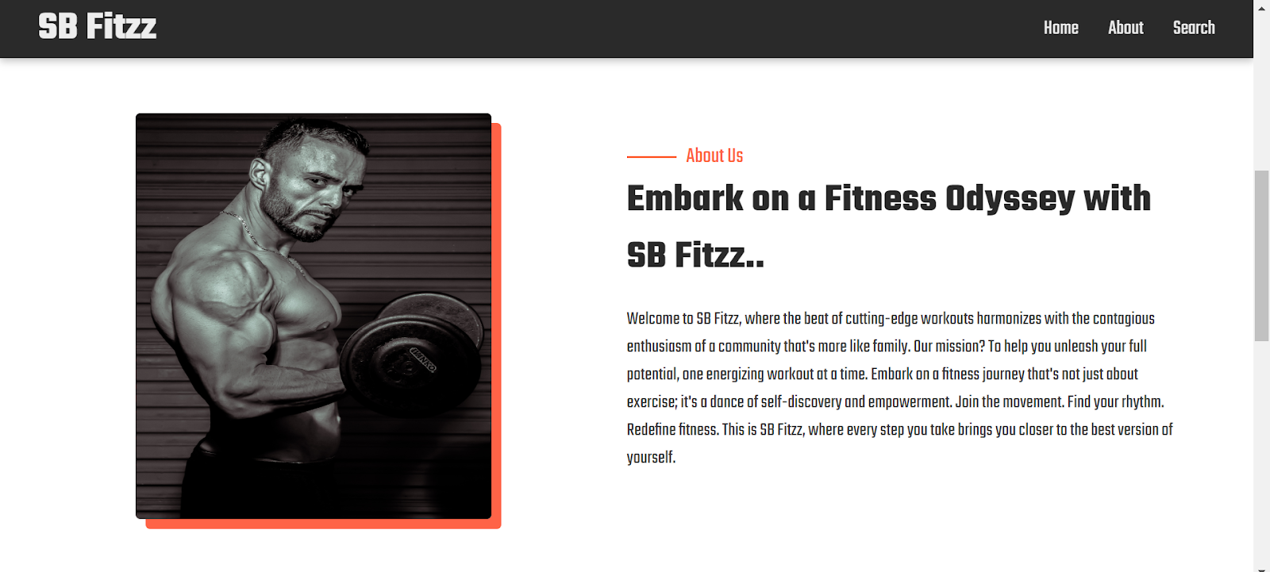

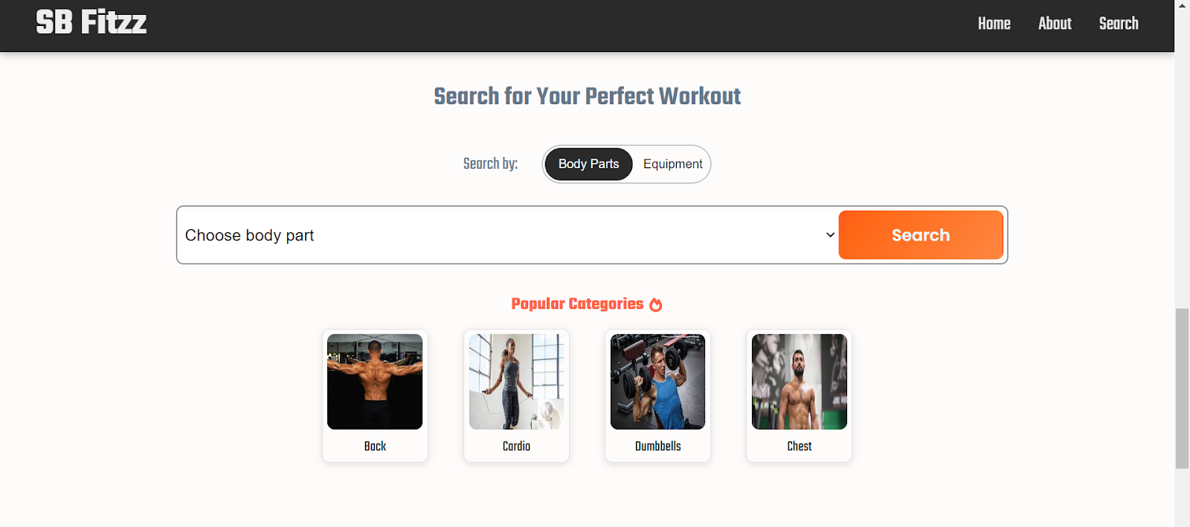

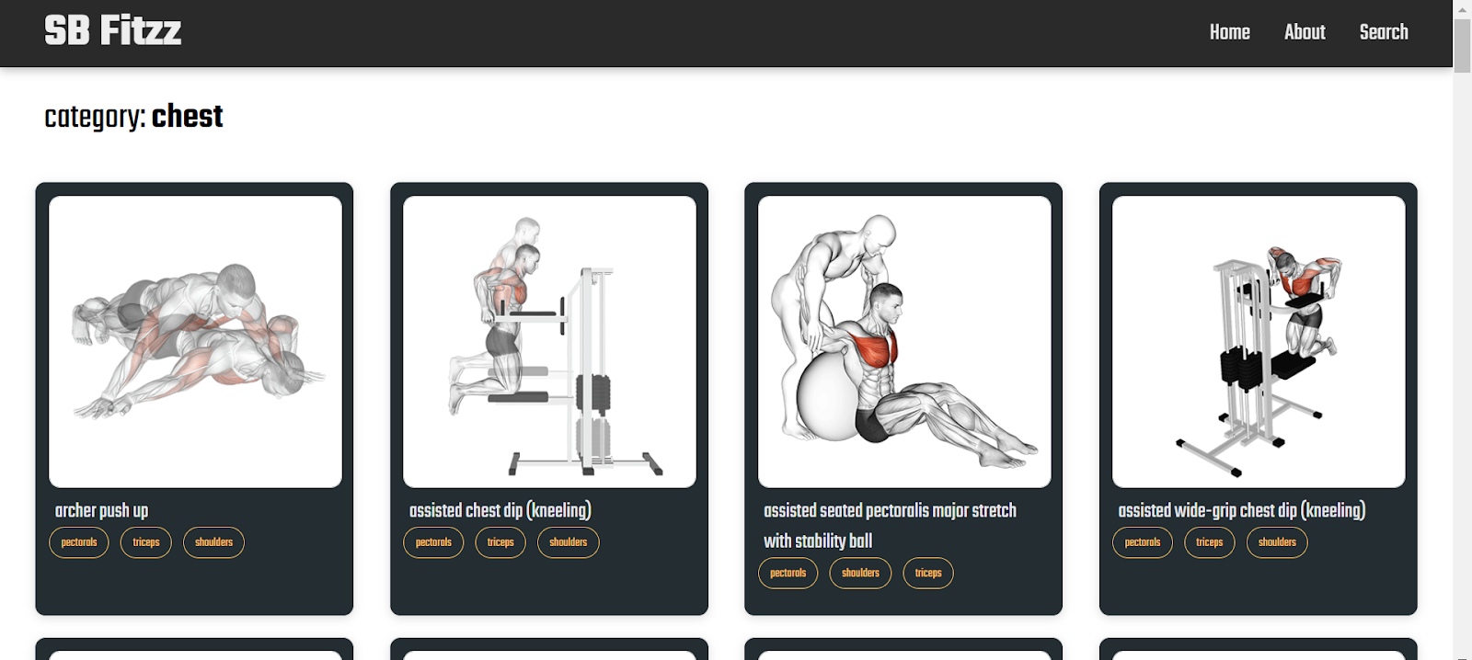

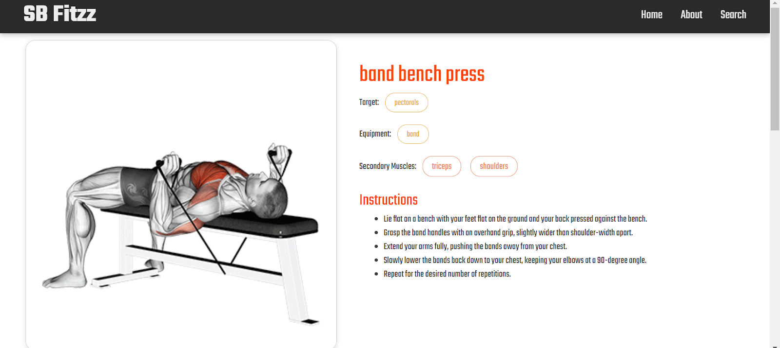

## 12. Known Issues

• Minor UI responsiveness issues on smaller devices.

## 13. Future Enhancements

• Integration with wearable devices

• AI-driven workout recommendations

• Advanced analytics with data visualization

• Voice-assisted workout guidance